**Using RecobundlesX**:

*Author: Bryce Geeraert – August 21, 2020*

Where are the relevant files?

What are the steps?

1. Manual tractography in a set of exemplar subjects
   1. ***Postdoc_scripts/Diffusion_processing/Tractography/Mrtrix_manual_tractography_v1.py***
   2. ***Syntax: Mrtrix_manual_tractography_v1.py <group> <subject> <tract> initialize***
      1. This opens mrview and loads up the dwi and rgb images for a subject
      2. This also creates an output folder for manually saved ROIs and auto-generated tract outputs
   3. Draw ROIs for your tract of interest
      1. Save them in the tract folder ‘…Venus/RecobundlesX/1_Bryce_manual_tractography/’+bin+’/’+subject+’/’+tract
   4. Once ROIs are drawn, ***Mrtrix_manual_tractography.py <group> <subject> <tract>***
      1. Tract is saved with # not and # and rois in the name
   5. Check tract results in mrview or mi-brain
   6. Once happy with tracts, log and rate in Excel spreadsheet ‘BG Data Quality Ratings <date>’
   7. Additionally **COPY ALL COMPLETED TRACTS** to a standalone folder for step 2.
2. Once tracts are finished in your chosen set of exemplar subjects (5 TDC, for example), transform them into atlas tracts suitable for RecobundlesX
   1. ***Postdoc_scripts/GitHub/RecobundlesX/RecoX_create_atlas_tracts/create_Recox_template_BG_v3.py***
   2. ***Syntax: create_Recox_template_BG_v3.py***
      1. Concept: run the script, script asks for a directory, once you give that directory the tck files within will be fully processed intelligently (steps skipped if already complete).
      2. Once done, the folder will look like:

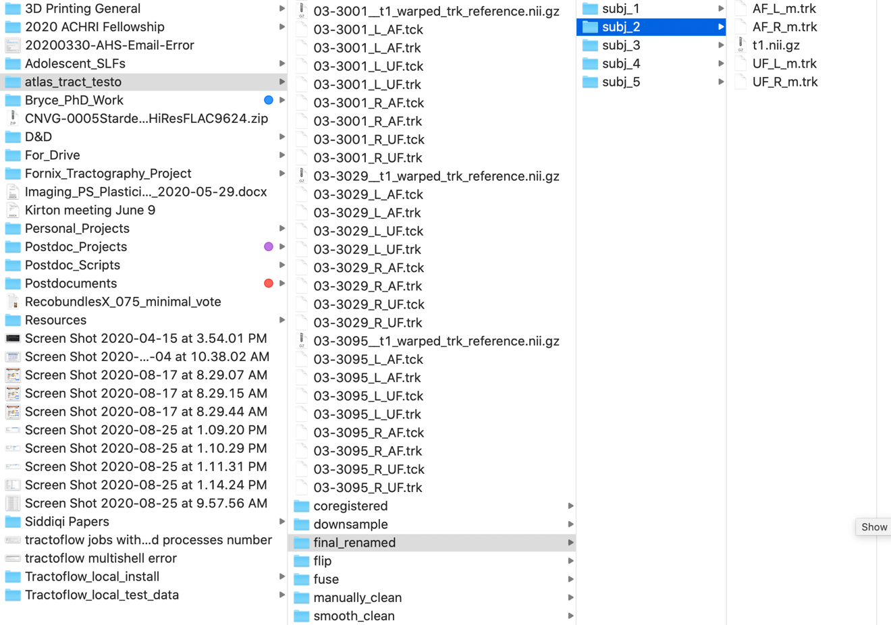

* + 1. This processing requires a manual check of streamline clusters, when we get to this step the script waits for a y/n answer before proceeding to cluster checks
       1. NOTE: in the cluster check window, a = accept, r = reject (I think), q = quit. Quit after all clusters have been checked
       2. NOTE: my approach so far has been ‘if a cluster follows a main trajectory of the tract, keep it. If it is a smaller or self-contained cluster in one region of the tract only, toss it.’
    2. V3 of this script pushed to GitHub Aug 25, 2020
    3. Final step = copy resultant atlas tracts to anonymized ‘final_renamed’ folder with properly formatted names

1. Once atlas tracts have been fully processed, RecobundlesX may commence
   1. ***Postdoc_scripts/Diffusion_processing/RecoBundles/RecobundlesX_tractography_v4.py***
   2. ***Syntax: RecobundlesX_tractography_v4.py***
      1. Configuration: **dir_data** must point to folder containing only (and ALL) data to be processed by RecoX:

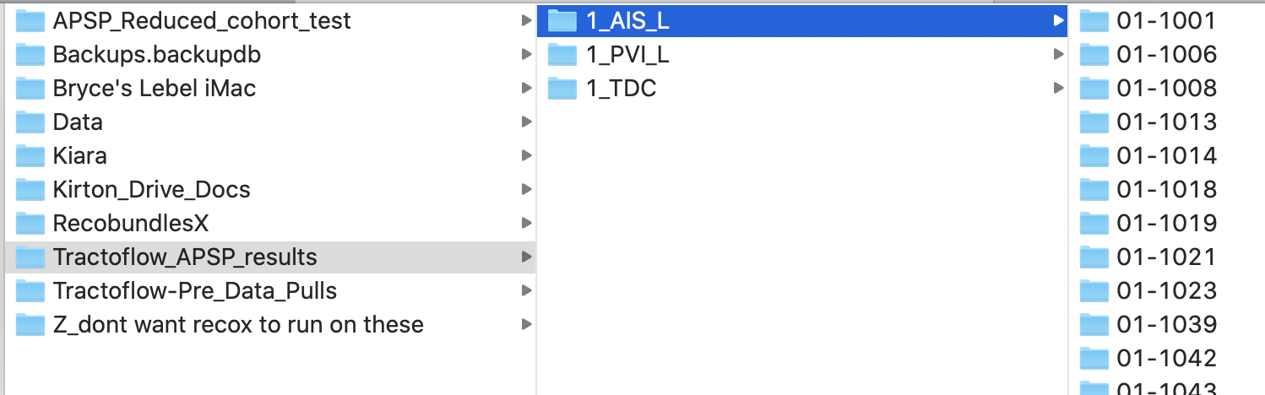

* + 1. **dir_RecoX** must point to folder where all tracts will be saved, organized by bin then subject tag:

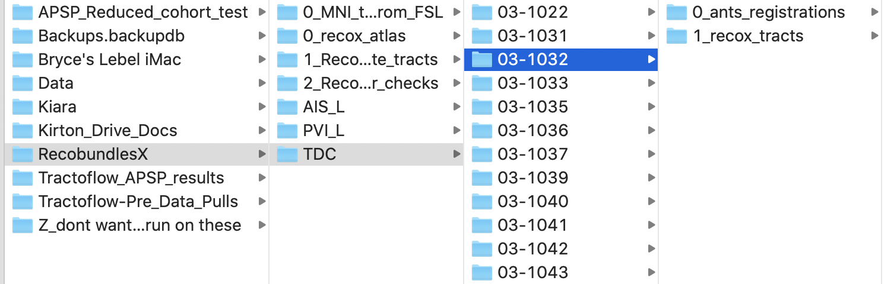

* + 1. Atlas tracts folder (containing subj_1 -> subj_# etc) should be moved to ***/Volumes/Venus/RecobundlesX/0_recox_atlas/atlas:***

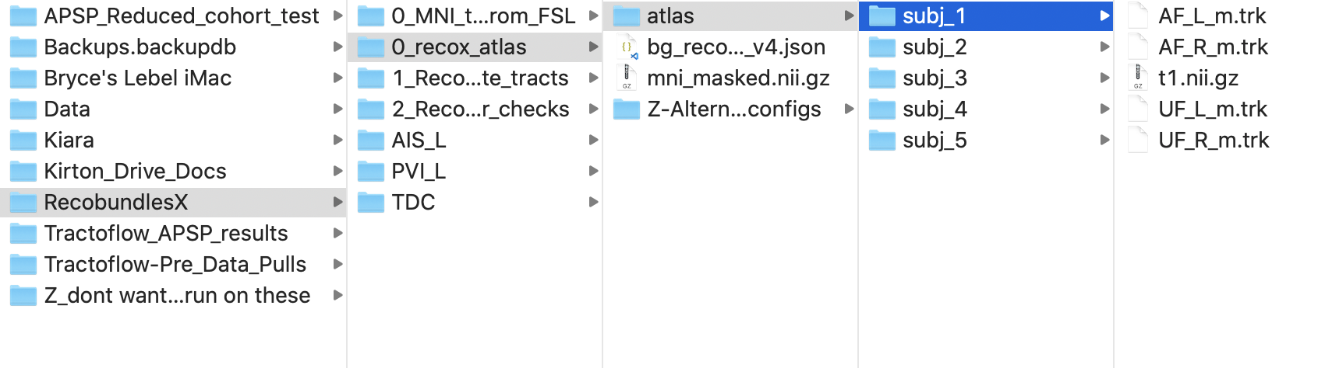

* + 1. **IMPORTANT CHECKS:**
       1. *Do the tract names in each subject folder EXACTLY MATCH the names contained in the config file? (currently used: bg_recox_config_v4.json)*
       2. *Does each subject folder contain all tracts AND t1.nii.gz as the anatomical reference?*
    2. This step, for ~70 subjects and 4 tracts, with 18 multiparameters and minimal vote 0.5, took **approx. 2 days** on my local iMac.